# Who wants to be a millionaire

## About program

Game "who wants to be a millionaire" - an analogue of the famous quiz game. This game will allow for the benefit of intelligence to spend leisure time.

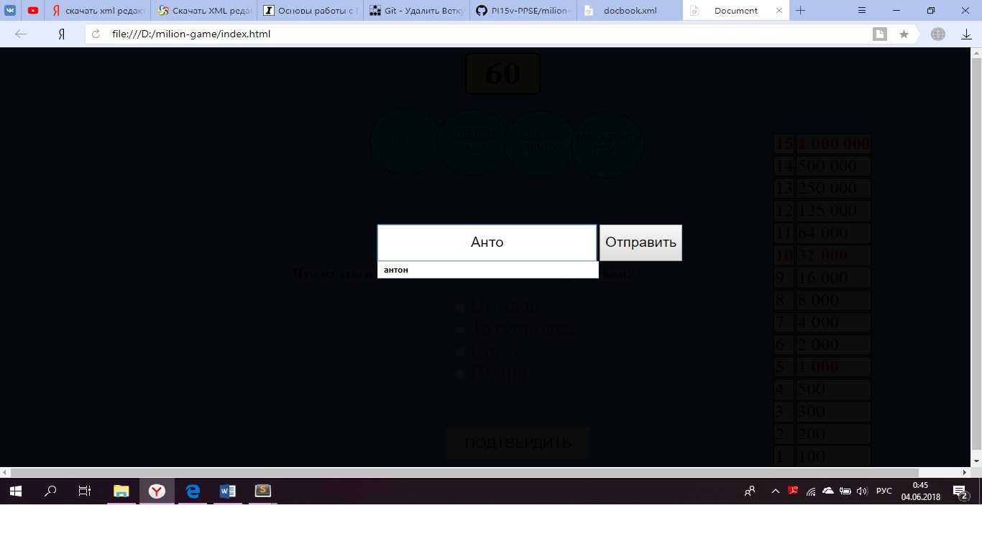

To start exchanging your knowledge for money, clone the repository <https://github.com/PI15v-PPSE/milion-game> Then open the browser file index.html

# Usage scenario

## Scenario 1 (Losing)

The user incorrectly answers a quiz question

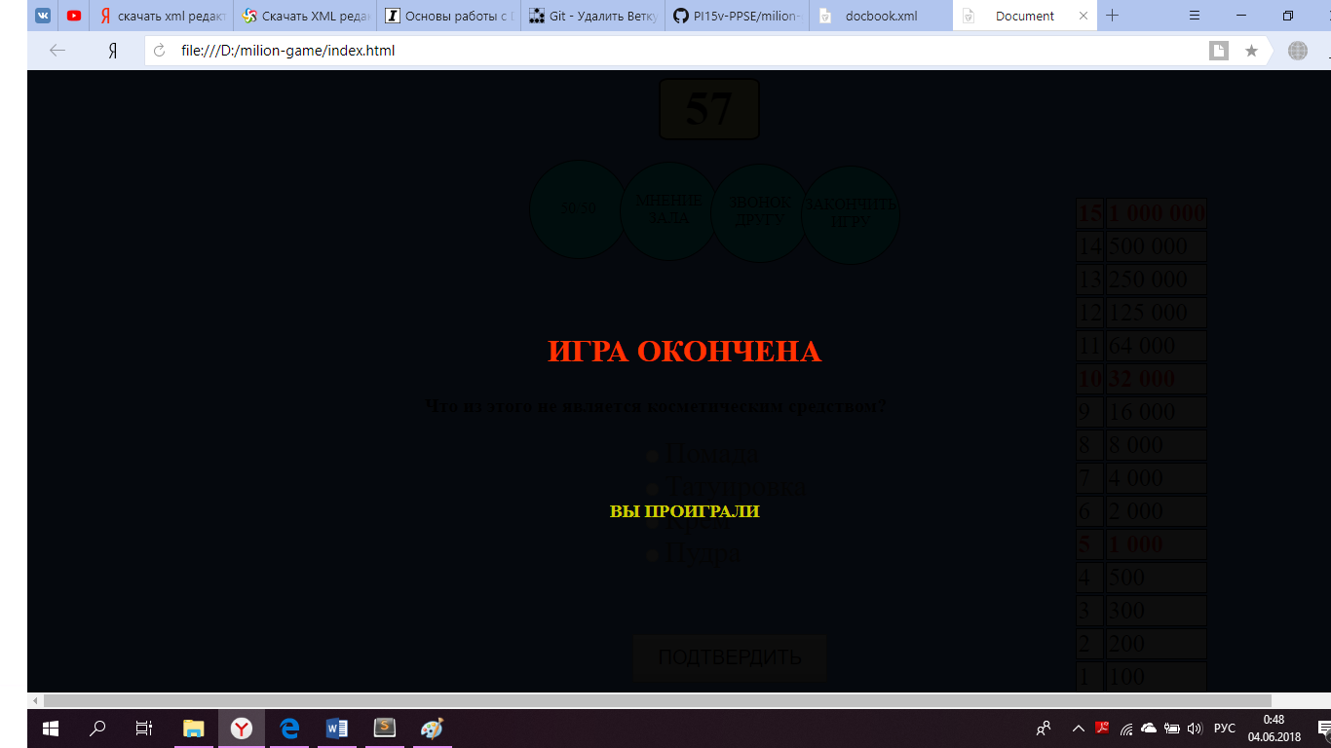

Player won

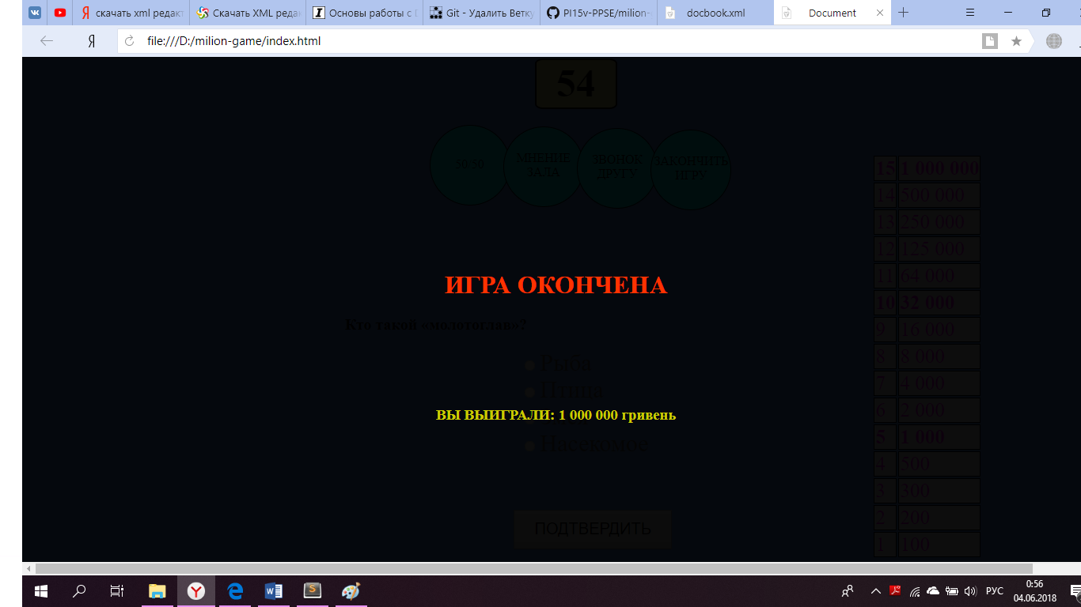

The player chooses a hint 50/50.

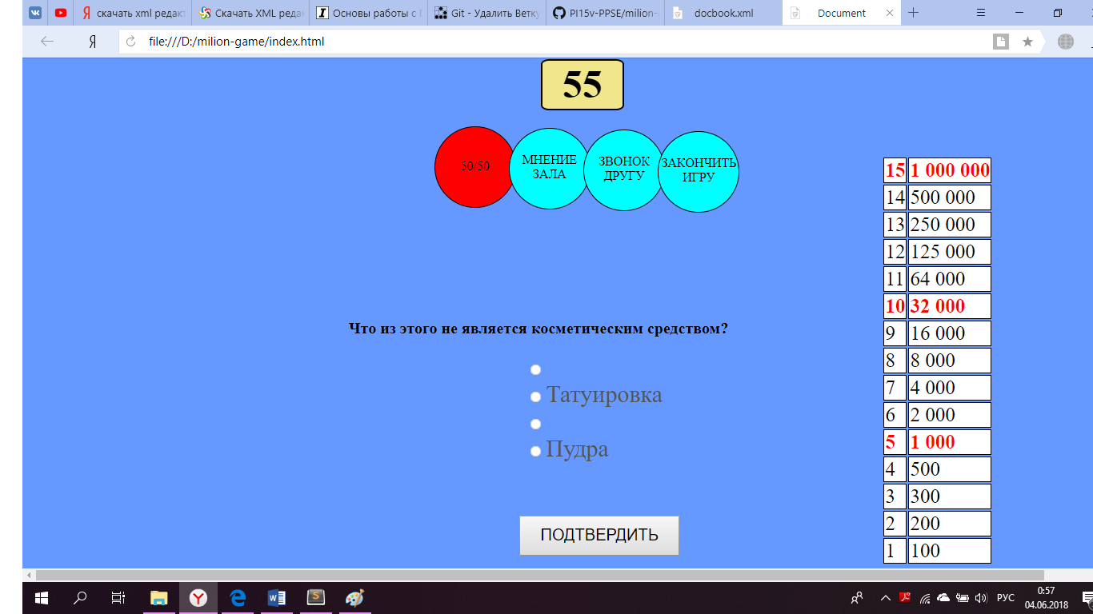

## Verification of the "player name" field is provided by the following code:

if (username != null)

{

$('.start').css('display', 'none');

$('.reStart').css('display', 'block');

$('.hellow').text('С возвращением, ' + username + '!');

$('#startGame').click(function(){

$('.reStart').css('display', 'none');

setTimeout(timer,1000);

});

}

Here is the check for the correct answer if the test passed the following question not the end of the game.

if( $('input[name=answer]:checked').val() == key[level] )

{

level++;

show(level);

}

else{gameOwer()}

$('input').prop('checked', false);

$(tr.css('background','#fff'));

$(tr.removeClass('result'));

$(tr[tr.length - (level + 1)]).css('background','#FF0');

$(tr[tr.length - (level)]).css('color','#f0f');

$(tr[tr.length - (level)]).addClass('result');

$('label').css('color', '#555');

A function that performs an action when the player answers incorrectly

function end() {

$('.end').css('display', 'block');

if (tr.hasClass('result'))

{

var tdResult = $("tr.result").children();

var tdText = tdResult[1].textContent;

$('.showResult').text('YOU WON: ' + tdText + ' rub');

}

Here in the handler function, the Function creates a cook with basic parameters